UK Declaration of Conformity



UK Declaration of Conformity

|  |  |
| --- | --- |
| **Model Number:** | AT-ETU-SYNC |

|  |  |
| --- | --- |
| **Product Name:** | Ultra High Data Sync Corrector and EDID Manager |

|  |  |
| --- | --- |
| **Authorized Manufacturer:** | Atlona, Inc.  70 Daggett Drive San Jose, CA 95134 USA  (408) 962-0515 |

This product conforms with the provisions of the following UK regulations, including all amendments, and with national legislation implementing these regulations.

|  |  |
| --- | --- |
| **Regulations:** | Electromagnetic Compatibility Regulations 2016  The Restriction of the Use of Certain Hazardous Substances in Electrical and Electronic Equipment Regulations 2012 |

The following harmonized standards were applied:

|  |  |
| --- | --- |
| **Standards:** | BS EN 55032  BS EN 55024 |

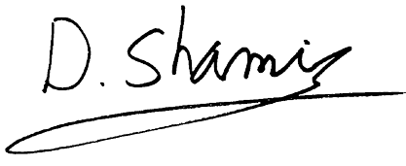This product carries the UKCA mark, which was affixed in 2021.

|  |  |
| --- | --- |
| **Authorized Signatory:** | David Shamir, Vice President Product Management |

|  |  |
| --- | --- |
| **Date:** | May 25, 2021 |

|  |  |
| --- | --- |
| **Place:** | San Jose, CA, USA |