UK Declaration of Conformity

UK Declaration of Conformity
Model Number: | AT-GAIN-120

Product Name: | Atlona 120 Amplifier

Authorized Manufacturer: | Atlona, Inc.  70 Daggett Drive San Jose, CA 95134 USA  (408) 962-0515

This product conforms with the provisions of the following UK regulations, including all amendments, and with national legislation implementing these regulations.

Regulations: | Electromagnetic Compatibility Regulations 2016  The Restriction of the Use of Certain Hazardous Substances in Electrical and Electronic Equipment Regulations 2012  Electrical Equipment (Safety) Regulations 2016

The following harmonized standards were applied:

Standards: | BS EN 55032  BS EN 55024  BS EN IEC 62368-1

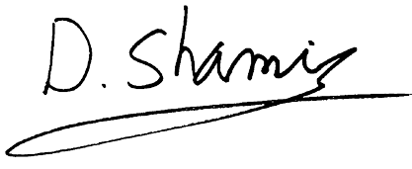
This product carries the UKCA mark, which was affixed in 2021.

Authorized Signatory: | David Shamir, Vice President Product Management

Date: | May 25, 2021

Place: | San Jose, CA, USA

