UK Declaration of Conformity

UK Declaration of Conformity

Model Numbers: | AT-UHD-EX-100CE-TX-PD,  AT-UHD-EX-100CE-RX-PSE

Product Name: | HDMI signal extender using HDBaseT extension

Authorized Manufacturer: | Atlona, Inc.  70 Daggett Drive San Jose, CA 95134 USA  (408) 962-0515

This product conforms with the provisions of the following UK regulations, including all amendments, and with national legislation implementing these regulations.

Regulations: | Electromagnetic Compatibility Regulations 2016  The Restriction of the Use of Certain Hazardous Substances in Electrical and Electronic Equipment Regulations 2012

The following harmonized standards were applied:

Standards: | BS EN 55032  BS EN 55035

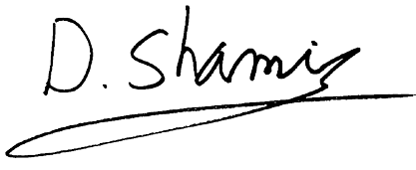
This product carries the UKCA mark, which was affixed in 2022.

Authorized Signatory: | David Shamir, Vice President Product Management

Date: | Feb 22, 2022

Place: | San Jose, CA, USA

